TECHNICAL SUPPORT DOCUMENT
2017 BASELINE WINTERTIME OZONE EMISSIONS INVENTORY:
OFF-ROAD MOBILE SOURCES
OPERATING WITHIN THE OIL AND GAS FIELDS
LOCATED IN THE UINTAH, UT NONATTAINMENT AREA

MARCH 2020
Utah Division of Air Quality
Planning Branch/Mobile Sources

Abstract

This report discusses the 2017 baseline wintertime ozone emissions inventory for off-road mobile sources that operate within the oil and gas fields located in the Uintah, UT Non-Attainment Area (NA).

Off-road mobile inventories were calculated using emission factors generated by the EPA MOVES2014b (Motor Vehicle Emission Simulator) utilizing the movesdb20181022 default database. Off-road vehicle activity per well type of activity was provided a 2011 Environ Study Table 3 Weighted average on‐road traffic data¹(see Table 1). Production activity by product type calculation was provided by Western Energy Alliance (Alliance) and the Utah Petroleum Association (UPA). 2017 production activity and active well counts were provided for by the DAQ Technical Analysis Section from the Utah Division of Oil, Gas, and Mining.

Agencies that developed the 2017 baseline off-road mobile source inventory:

Uintah Basin, UT Ozone NA:

Utah Division of Air Quality (UDAQ) and the Utah Department of Transportation (UDOT)

Summary Table for the 2017 baseline wintertime ozone emissions inventory for oil and gas off-road mobile sources are located on page 15-16.

3.) OFF-ROAD MOBILE SOURCES INVENTORIES

i. Table of Contents……………………………………………………………………......... 3
ii. Glossary of Acronyms……………………………………………………………………… 4
iii. Overview………………………………………………………………………................. 5
iv Emission Factors………………………………………………………………………..... 5
v. MOVES Modeling Procedure............................................................................................ 6

vi. Emissions Calculations ….................................................................................................... 9

vii. Appendix: Baseline Year Inventories………………………………………………………. 17

viii. References………………………………………………………..….................................. 17

LIST OF TABLES

Table 1 Environ Oil and Gas Mobile Sources Pilot Study; Prepared for: U.S.
Environmental Protection Agency Work Assignment 4-08. July 2011
Table 3 Weighted average on‐road traffic data…………………………… 10-11
Table 2 MOVES Generic Emission Factors……………………………………........... 12

Table 3 MOVES Weighted Idle Emission Factors……………………………............. 13

Table 4 2017 Annual Production…….………………………………………………… 14

Table 5 2017 Annual Active Wells.………………………………………………........ 14

Table 6 Duchesne Off-Road Inventory………………………………………………… 15

Table 7 Uintah Off-Road Inventory………………………………………………........ 16

ii. Glossary of Acronyms:

Alternative Vehicle and Fuels & Technology: (AVFT)

Barrels (bbl)

County Data Manager: (CDM)

MOVES2014b: (Motor Vehicle Emission Simulator)

Nonattainment Area: (NA)

Utah Division of Air Quality (UDAQ)

Utah Department of Transportation: (UDOT)

Utah Petroleum Association (UPA)

Vehicle Hours Traveled: (VHT)

Vehicle Miles Traveled: (VMT)

Western Energy Alliance: (Alliance)

iii. Overview

The purpose of this document is to explain the emissions modeling assumptions used to develop the 2017 baseline wintertime ozone emissions inventory for off-road mobile sources that operate within the oil and gas fields located in the Uintah, UT Non-Attainment Area (NA).

Agencies that developed the 2017 baseline for the Uintah Basin, UT Ozone NA:

Utah Division of Air Quality (UDAQ) and the Utah Department of Transportation (UDOT)

iv. Emissions Factors

The following procedures were used to develop emission factors for the off-road mobile source operating within the oil and gas fields

- Emission Factor Development
Emission factors were developed utilizing the EPA approved MOVES2014b (Motor Vehicle Emission Simulator) model with the following default database: movesdb20181022. The inventory mode was used to create two types of emission factor estimates. The first emission factor estimate involves creating a generic rate from all of the emissions processes and vehicle miles travel (VMT) output based on speeds from the 2011 Environ Study Table 3 Weighted average on‐road traffic data¹ (see Table 1). The second emission factor from the inventory mode involves utilizing the project mode and creating an idle emission factor.

Document research was conducted and identified a different activity method being used by the Colorado Air Resource Management² and Bureau of Land Management Utah Air Program³ for areas similar to the Uintah Basin. The vehicle activities listed by both agencies are identical to each other but are not referenced as to how they were created, the types of roads that are covered, and where those roads are located (within and/or outside the oil field). These studies do not include average speed for each identified activity and do not include idle emissions. The 2011 Environ study activity data was selected because it includes references and provides more specific activity data.

- Generic Rate

The inventory mode was used within MOVES to produce a generic emissions rate for off-road vehicles. The inventory mode provides emissions estimates in tons per average weekday and are divided by VMT to produce a generic rate for off-road vehicles in grams per mile of activity. The emissions processes used to create the rate include starts, exhaust, evaporative, and hotsoak emissions. This method is more conservative than the rates mode because it contains more emissions detail. The 2011 Environ Study Table 3 Weighted average on‐road traffic data identified the following off-road mobile sources that operate within the oil and gas fields: gasoline and diesel light duty commercial trucks and diesel combination short haul trucks. MOVES was setup to produce output based on these vehicle types.

Similar inputs from the 2017 Baseline on-road mobile inventory were used to create the generic rate for off-road vehicle inventory except for the speed profiles. The shared inputs include vehicle fuel profiles and specifications, VMT, VMT mix, vehicle age distributions, and meteorological conditions. The logic in this modeling setup is that the vehicles operating on-road within the non-attainment area have the same vehicle characteristics as those operating off-road within oil and gas fields within the non-attainment area. Without any vehicle characteristic data for off-road vehicles operating within the oil and gas fields, this is the best assumption that can be made. In addition to the inputs mentioned above, the only input profile that changed from the on-road input is the average speed activity input. The speed activity data for the off-road mobile inventory was provided by the 2011 Environ Study Table 3 Weighted average on‐road traffic data (Table 1) .

- Idle Rate
The inventory mode was also used to construct emission factors for idling emissions. Idle emission factors are obtained from MOVES using the same vehicle characteristics and speed profiles used to create the generic emission rates. When MOVES is run under a project level inventory, it will provide idle emission factors. The 2011 Environ Study Table 3 Weighted average on‐road traffic data (Table 1) provides idle hours per well activity by vehicle type to coincide with the idle emission factors from MOVES.

v. MOVES Modeling Procedure

1. MOVES Default Database

EPA MOVES2014b: movesdb20181022

2. MOVES2014 Daily Pollutants

- Ammonia (NH3)
- Carbon Monoxide (CO)
- Oxides of Nitrogen (NOx)
- PM^{2.5} Exhaust (PM25_Ex)
- Volatile Organic Compounds (VOC)

3. MOVES2014 Local Model Inputs for Emission Factors

- County Data Manager Development
MOVES organizes data inputs into databases called County Data Manager (CDM) tables. CDMs were developed for Duchesne and Uintah counties for the 2017 baseline wintertime ozone emissions inventory for off-road mobile sources.

- Average Speed Distribution

Speed data provided by the 2011 Environ Study¹ Table 3 was used to calculate a weighted 24 hour average speed for rural unrestricted access roads. The dirt roads within the oil and gas fields within the basin experience very little traffic and delay so a 24 hour speed profile replicates that activity. The weighted speeds calculations were based on the fraction of VMT per well traffic activity defined by vehicle type. This calculation resulted in separate speed profiles for light commercial trucks and combination short haul trucks.

- AVFT (Alternative Vehicle and Fuels & Technology: Electric, Diesel and Gasoline Vehicle Fractions)

The MOVES default file for AVFT was updated with 2018 State DMV registration data (dated January 1, 2018). The DMV fuel split data is for all model years for registered light duty vehicles (passenger cars and light duty trucks) and is not available for model year. The DMV fuel data is adjusted to match the DMV age distribution data.

DMV data AVFT Model Years
2018 2050-2017
2017 2016
2016 2015
2015 2014-1960

MOVES2014b default AVFT values were used for all remaining source type vehicles.

- Fuel

An adjustment was made for 2017 to account for gasoline sulfur level in Utah since small volume refiners are not required to comply with federal Tier 3 gasoline (10 ppm sulfur) requirements until January 1, 2020. EPA Office of Transportation and Air Quality (OTAQ) provided 2017 local gasoline sulfur values of 20.9 ppm. MOVES 2014a default fuel parameters were used for diesel and CNG.

- HourVMTFraction
MOVES2014b default Hour VMT Fraction values were used.

- HPMSvTypeYear (VMT)
UDOT State Travel Demand Model provided VMT inputs for MOVES. The State TDM analyzed thousands of separate traffic segments called "links" that together comprise the network of roads of Duchesne and Uintah County. Each link is assigned, for each of the four major time periods during the day (AM peak, midday, PM peak and nighttime), an average speed, an increment of VMT and an increment of VHT (vehicle hours traveled). A specific number of links are assigned to each of the UDOT HPMS functional classes (road types, e.g., rural local, urban local, rural minor arterial, urban minor arterial, and so on). In effect, average speeds, VMT and VHT for each of the functional classes are combined to obtain average speed, VMT and VHT for rural arterials, urban arterials, rural local roads and urban local roads. Seasonal factors for highway VMT variations have been revised and refined by UDAQ with data supplied by the UDOT. Seasonal factors are determined by functional class (freeway or arterial) for each county.

- Road Type Distribution

UDOT Division of Systems Planning and Programming provided 2017 VMT travel fractions for FHWA vehicle classes grouped by Gross Vehicle Weight Rating (GVWR) ranges. The travel fractions were obtained by county from automated pneumatic counters that detect axle spacing and "weigh-in motion" (WIM) counters placed on arterial, interstate, and local roads. VMT and Vehicle Mix data were used to construct road type distribution and VMT by sourcetype.

- Source Type Age Distribution & Source Type Year

The 2017 vehicle age distribution data and source type vehicle population for vehicle types 11, 21, 31, and 32 (motorcycles, passenger cars, passenger trucks, and light duty commercial trucks up to 10,000 GVWR) was based on 2018 Utah DMV registration data (dated January 1, 2018). The first model year of 2018 vehicle counts were removed and the first model year used is 2017 through 1969. This count provides a conservative snapshot of the vehicle fleet where it ensures that all of the 2017 model years sold are included and removes a small fraction of the 2018 model year. The MOVES default vehicle fraction count data for passenger cars, passenger trucks, and light duty commercial trucks was used to determine the vehicle population for these vehicles since the DMV data cannot discern between a passenger car (21) and light duty trucks (31,32). MOVES default age distribution and vehicle population counts are used for the remaining heavy duty vehicle types because the state DMV data is incomplete, does not match MOVES vehicle types, or does not cover all the heavy duty vehicle types that are registered in other states traveling within the state of Utah.

(8) ZoneMonthHour (Meteorological Data)

The UDAQ Technical Analysis Section provided metrological conditions from the airport in Vernal, Utah from the MesoWest archives. Mesowest (mesowest.utah.edu) is a database of current and archived meteorological data from weather stations in the United States maintained by the University of Utah. The meteorological data is an hourly average temperature and relative humidity from an ozone exceedance event that occurred in the Uintah, UT Non-attainment area from February 1-10, 2013.

vi. Emissions Calculations:

Generic and idle emission factors were initially created separately for Duchesne and Uintah counties. To create an aggregate generic and idle emission factor the VMT from the on-road inventory was used to create a weighted average emission factor that would cover all of the off-road activity occurring within the oil and gas fields. (See Table 2 & 3) This method provides a generic and idle emission factor to be multiplied by their respective oil and gas off-road mobile activity that occurs per well type of activity. VMT and idle activities are provided by The 2011 Environ Study Table 3 Weighted average on‐road traffic data (See Table1).

Production traffic trips and idle time activities for Heavy Duty Diesel Trucks have been replaced according to the 2020 Alliance memo⁴. The new factors rely upon local data and are more accurate than what is provided in the 2011 Environ study. The new trip activity is based on the product produced (oil, water, condensate) and divided by the production truck load out volume (280 barrels (bbl) per oil truck, 130 bbl per water/condensate truck). The production numbers are for 2017 from the Utah Divison of Oil and Gas, and Mining and includes annual water, condensate and oil (See Table 4). Produced water may be removed from the production site via truck loading, through piplines, or evaporated or injected directly on site. Produced water in this calculation assumes that all produced water is loaded onto a truck and disposed of off site. This assumption is conservative resulting in an overestimation of truck loading for produced water in volume in 2017. The produced product is divided by the number of active wells to produce annual trips per well type (See Table 5). Average Idle time was assigned according to how long it takes to fill a truck: oil trucks takes 60 minutes and condensate or water truck takes 45 minutes. The new production traffic round trips per activity for Heavy Duty Trucks has been updated from 3 trips to 68 trips per year. The idle activity per trip has been updated from 0.3 hours to 0.97 hours.

VMT is based on oil and gas round trip distances and round trips per activity. Idle hours is based on engine-on idle time per trip and round trips per activity. All of the activities used occur within the oil and gas field. Off-road mobile activities (trips and idle hours) are split into the following categories for a single well: well pad construction, pipeline activity, drilling, completion, recompletions, production traffic, maintenance, ancillary, and employee commuter. The emissions for a single well are summed to create an annual emissions inventory. The annual emissions from a single well is multiplied by the total number of active wells to produce an annual emissions inventory. The 2017 active well counts are provided at the county level. The DAQ Technical Analysis section provided the county well count data from the Utah Division of Oil, Gas, and Mining. The resulting off-road mobile emissions inventories can be found in Table 6 for Duchesne County and Table 7 for Uintah County.

- Environ Oil and Gas Mobile Sources Pilot Study; Prepared for: U.S. Environmental Protection Agency Work Assignment 4-08. July 2011 Table 3 Weighted average on‐road traffic data

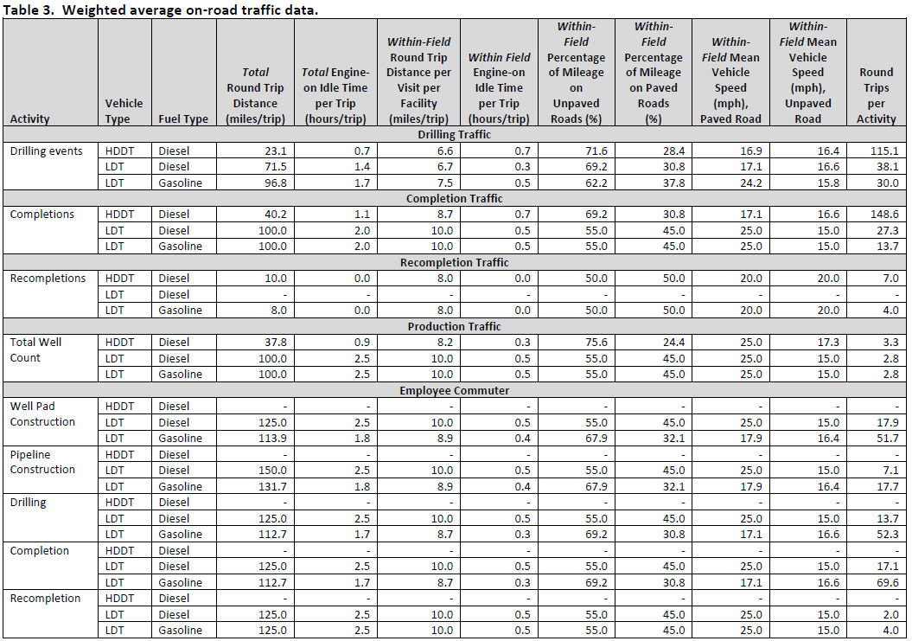

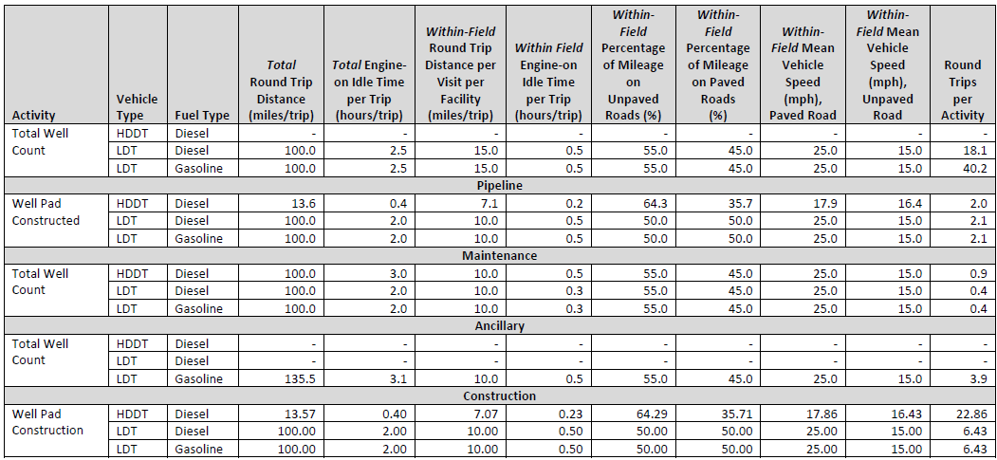

Table 2 MOVES Generic Emission Factors

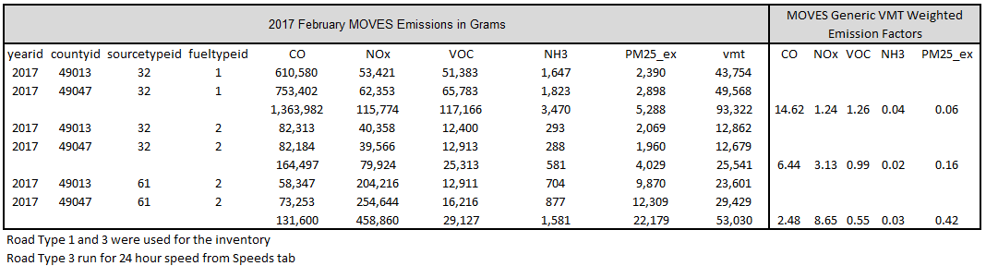

Table 3 MOVES Weighted Idle Emission Factors
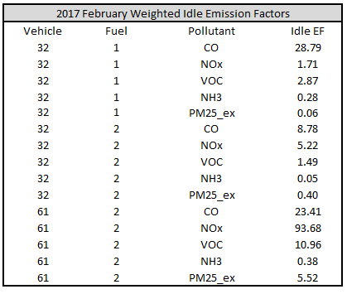

Table 4 2017 Annual Production

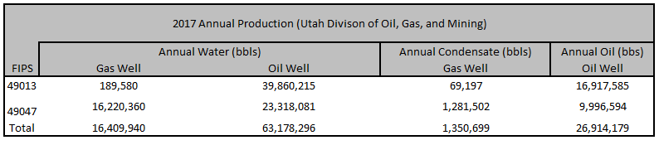

Table 5 2017 Annual Active Wells

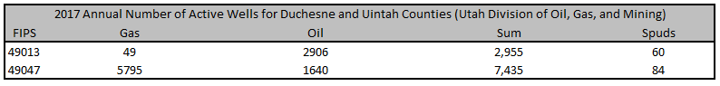

Table 6 Duchesne Off-Road Inventory
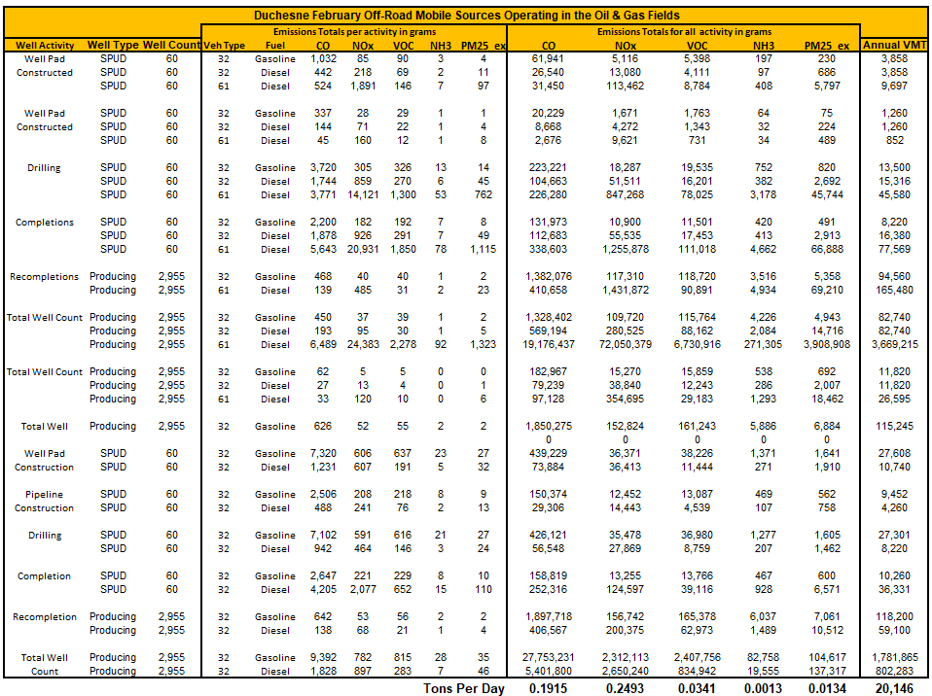
Table 7 Uintah Off-Road Inventory
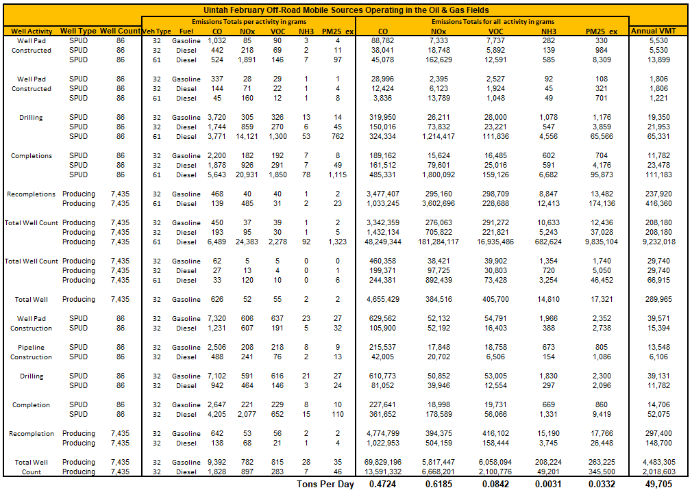

vii. Appendix: Baseline Year Inventories

Input files will be furnished upon request.

viii. References

- Environ Oil and Gas Mobile Sources Pilot Study; Prepared for: U.S. Environmental Protection Agency Work Assignment 4-08. July 2011

- March 2016 Ramboll Environ Colorado Air Resource Management Modeling Study (CARMMS) with updated Mancos Shale Modeling CARMMS 1.5 Final Report

- https://www.blm.gov/sites/blm.gov/files/program_natural%20resources_soil%20air%20water_airut_quick%20links_OilTemplateMOABMLP.xlsx

- April 2, 2020 Western Energy Alliance and Utah Petroleum Association Memo RE: Uintah Basin 2017 Emissions Inventory Request for Additional Information

